**Oliver Sheard – U1664298**

**CIS 2344 – Algorithms Processes and Data**

**Contents**

**Logbook Exercises**

Week 1 & 2 Randomisation and Testing Page 01

Week 3 & 4 Generics Page 04

Week 5 Sorting Algorithms Page 05

Week 6 Lists TEST Page 10

Week 7 Binary Trees TEST Page 12

Week 8 Hashtables Page 14

Week 10 Graphs TEST Page 16

Week 11 Topological Sorting TEST Page 17

Week 13 Counter Behaviours MAX Page 18

Week 14 Railway System Page 19

Week 15 Semaphore Page 20

Week 16 Monitors Page ??

Week 17 Modelling Circuits Page

Week 20 Quantum Computing ? Page

**Self-Assessment**

Semester 1 Guidance Week Page

Semester 1 Consolidation Week Page

Semester 2 Guidance Week Page

Semester 2 Hand-in Week Page

**Logbook Assignment Submission**

Week 1 & 2 – Randomisation and Testing

Clever Random Listing Class

/**

* Randomise the array by individually swapping each index value with a random

* element in the array

*/

**protected** **void** randomise()

{

**for**(**int** p=0;p<getArray().length;p++)

{

**int** tempIndex = getRandomIndex();

**int** tempValue = getArray()[p];

getArray()[p] = getArray()[tempIndex];

getArray()[tempIndex] = tempValue;

}

}

Although using java.Collections would be more efficient via shuffle(List <T> list) the use would defy the point of the exercise.

Edits to Random Listing to implement timing of randomisation

/**

* Generate an array containing elements in a random order

*

* **@param** size the length of the array to be generated

*/

**public** RandomListing(**int** size)

{

**super**(size);

startTime = System.nanoTime();

randomise();

endTime = System.nanoTime();

System.out.println("Randomisation for length " +size + " took " + (endTime-startTime)/1000 + " microseconds");

}

This constructor is inaccurate in recording the time taken to complete randomisation, this is due to the function passing data to the superclass prior to taking the System time, although inaccurate in this manner when comparing multiple uses of the function the inaccuracy is null as each use has the same flaw.

Testing the CleverRandomListing class

The test class for CleverRandomListing is a duplicate of the SimpleRandomListingTest class given in the tutorial zip file and modified to apply the same tests to the new randomise() function within the CleverRandomListing class, as shown below:

**package** intArrays;

**import** **static** org.junit.Assert.*;

**import** org.junit.After;

**import** org.junit.AfterClass;

**import** org.junit.Before;

**import** org.junit.BeforeClass;

**import** org.junit.Rule;

**import** org.junit.Test;

**import** org.junit.rules.TestName;

**public** **class** CleverRandomListingTest **extends** ListingTest {

**private** **static** **long** *testStart*, *testEnd*;

@BeforeClass

**public** **static** **void** setUpBeforeClass() **throws** Exception {

}

@AfterClass

**public** **static** **void** tearDownAfterClass() **throws** Exception {

}

@Rule **public** TestName testName = **new** TestName();

@Before

**public** **void** setUp() **throws** Exception {

*testStart* = System.*nanoTime*();

}

@After

**public** **void** tearDown() **throws** Exception {

*testEnd* = System.*nanoTime*();

System.***out***.println("Test \"" + testName.getMethodName() + "\" took " + (*testEnd*-*testStart*)/1000 + " microseconds");

}

@Test

**public** **void** testOneSize() {

testSize(1,**new** CleverRandomListing(1));

}

@Test

**public** **void** testOneContents() {

testContents(1,**new** CleverRandomListing(1));

}

@Test

**public** **void** testTwoSize() {

testSize(2,**new** CleverRandomListing(2));

}

@Test

**public** **void** testTwoContents() {

testContents(2,**new** CleverRandomListing(2));

}

@Test

**public** **void** testFourSize() {

testSize(4,**new** CleverRandomListing(4));

}

@Test

**public** **void** testFourContents() {

testContents(4,**new** CleverRandomListing(4));

}

@Test

**public** **void** testHundredSize() {

testSize(100,**new** CleverRandomListing(100));

}

@Test

**public** **void** testHundredContents() {

testContents(100,**new** CleverRandomListing(100));

}

@Test

**public** **void** testThousandSize() {

testSize(1000,**new** CleverRandomListing(1000));

}

@Test

**public** **void** testThousandContents() {

testContents(1000,**new** CleverRandomListing(1000));

}

@Test

**public** **void** testMillionSize() {

testSize(1000000,**new** CleverRandomListing(1000000));

}

}

An example of the test outputs is also presented below:

Randomisation for length 100 took 50 microseconds

Test "testHundredSize" took 2405 microseconds

Randomisation for length 1 took 2 microseconds

Test "testOneSize" took 77 microseconds

Randomisation for length 100 took 33 microseconds

Test "testHundredContents" took 510 microseconds

Randomisation for length 2 took 11 microseconds

Test "testTwoSize" took 57 microseconds

Randomisation for length 1 took 1 microseconds

Test "testOneContents" took 63 microseconds

Randomisation for length 2 took 1 microseconds

Test "testTwoContents" took 44 microseconds

Randomisation for length 1000 took 376 microseconds

Test "testThousandContents" took 7021 microseconds

Randomisation for length 1000000 took 23974 microseconds

Test "testMillionSize" took 27613 microseconds

Randomisation for length 4 took 51 microseconds

Test "testFourSize" took 124 microseconds

Randomisation for length 1000 took 103 microseconds

Test "testThousandSize" took 152 microseconds

Randomisation for length 4 took 0 microseconds

Test "testFourContents" took 57 microseconds

Week 3 & 4 - Generics

Generic element swapping in an array

/**

* Swap the position of two values in an array

* **@param** swap

* **@param** index1 position in an array for an object to be swapped

* **@param** index2 position in an array for an object to be swapped

* **@return** the input array with the modified values

*/

**public** **static** <T> T[] swapValues(T[] swap,**int** index1,**int** index2)

{

T temp = swap[index1];

swap[index1]=swap[index2];

swap[index2]=temp;

**return** swap;

}

Testing the swapping function

@Test

**public** **void** testSwapValues()

{

String[] names = {"Hugh","Andrew","Ebrahim","Diane","Paula","Simon"};

String[] swapped = {"Hugh","Paula","Ebrahim","Diane","Andrew","Simon"};

assertArrayEquals(swapped,GenericMethods.swapValues(names,1, 4));

}

@Test(expected=ArrayIndexOutOfBoundsException.**class**)

**public** **void** testSwapIndexError()

{

String[] names = {"Hugh","Andrew","Ebrahim","Diane","Paula","Simon"};

GenericMethods.swapValues(names, -1, 3);

}

@Test

**public** **void** testSwapValues2()

{

Integer[] integers = {1,2,3,4};

Integer[] swapped = {4,2,3,1};

assertArrayEquals(swapped,GenericMethods.swapValues(integers, 0, 3));

}

Week 5 – Sorting

Selection Sorting Class

**package** arraySorter;

/**

* The implementation of selection sort for an array of comparable elements

*

* **@author** Oliver Sheard

* **@version** October 2017

*/

**public** **class** SelectionSort<T **extends** Comparable<? **super** T>> **extends** ArraySortTool<T>

{

**public** **void** sort(T[] array)

{

**for**(**int** i = array.length-1; i>0;i--)

{

**int** max = 0;

T current = array[0];

**for**(**int** k=0; k<=i; k++)

{

**if**(array[k].compareTo(current)>0)

{

max = k;

current=array[k];

}

}

T temp = array[i];

array[i]=array[max];

array[max] = temp;

}

}

}

Quick Sorting Class

**package** arraySorter;

/**

* The implementation of the quick sort method for an array of comparable elements

*

* **@author** Oliver Sheard

* **@version** October 2017

*/

**public** **class** QuickSort<T **extends** Comparable<? **super** T>> **extends** ArraySortTool<T>

{

**public** **void** sort(T[] array)

{

//Initiate quick sort with full array

quicksort(array,0,array.length-1);

}

/**

* Performs the quick sort approach to organising an array

*

* **@param** array Array segment to be sorted (Includes full array)

* **@param** low Lowest index value of the section being sorted

* **@param** high Highest index value of the section being sorted

*/

**private** **void** quicksort(T[] array, **int** low, **int** high)

{

//Selects first element in the array to compare with all others

T compare = array[low];

**int** pivotIndex = low;

**for**(**int** i= low+1; i<=high;i++)

{

//Searches for elements smaller than first element

**if**(compare.compareTo(array[i])<=0)

{

//Swaps immediate neighbouring elements while shuffles

//elements that are further from the pivot index to an

//appropriate position

**if**(pivotIndex+1!=i)

{

swapElements(array,pivotIndex,pivotIndex+1);

}

swapElements(array,pivotIndex,i);

//Comparison element has moved up 1 index position,

//updates accordingly

pivotIndex++;

}

}

//No need to sort arrays of length 1

**if**(pivotIndex-low>1)

{

quicksort(array,low,pivotIndex-1);

}

**if**(high-pivotIndex>1)

{

quicksort(array,pivotIndex+1,high);

}

}

/**

* **@param** array Array that needs elements swapping

* **@param** index1 Position of the first value to be swapped

* **@param** index2 Position of the second value to be swapped

*/

**private** **void** swapElements(T[] array, **int** index1, **int** index2)

{

T temp = array[index1];

array[index1]=array[index2];

array[index2]=temp;

}

}

Comparison between Selection and Quick Sort

From the previous page, the graphs are plotting the average of three sets of raw data produced by the Timer classes for both the Selection and Quick sorting methods.

(Below) Duplicates of the data from the graphs with the raw data from Array Length 1,000-10,000 and 10,000 – 90,000 with a focus on the Quicksort data

As clearly displayed by the graphs, the initial difference in time taken for the arrays to be sorted is negligible (Arrays of length 1-1000) as the length of the array increases it become more apparent in how efficient the Quicksort method is in terms of arranging the array.

Regarding the formulae, the time complexity is commonly denoted as:

Θ(n log(n)) for Quicksort

Θ(n^2) for Selection Sort

In both cases n would be the length of the array and Θ would be a fixed variable for each script. By using the raw data provided it is possible to estimate a value for Θ. This has been done by taking the length of the Array, dividing by the average time for each point, accounting for any inconsistencies in the data and then taking the average from all these calculated values to produce a single value for Θ (Detailed below)

Quicksort Formulae - t(ms) = (3.69*10^-5)* n log(n)

Selection Sort Formulae – t(ms) = (7.94*10^-7)* n^2

(Where n is the length of the array to be sorted)

The left graphs show the average of three sets of results against formula calculations for arrays of length 1-1000, the right display the same data for arrays of length 1000-90000. The top row is specifically for Quicksort, while the bottom row is for Selection sort.

Week 6 - Lists

**package** linkedList;

**public** **class** Lists<T> **implements** List<T>{

**private** Node<T> startNode = **null**;

@Override

**public** **void** add(**int** index, T value) **throws** ListAccessError

{

Node<T> addNode = **new** Node<T>(value);

**if**(index ==0)

{

Node<T> temp = startNode.getNext();

startNode = addNode;

startNode.setNext(temp);

}

**else**

{

addNode.setNext(getNode(index));

Node<T> replacePoint = getNode(index-1);

replacePoint.setNext(addNode);

}

}

@Override

**public** T remove(**int** index) **throws** ListAccessError

{

**if**(index==0)

{

T returnVal = startNode.getValue();

startNode = startNode.getNext();

**return** returnVal;

}

**else**

{

Node<T> temp = getNode(index-1);

Node<T> overwrite = getNode(index);

T returnVal = (T) overwrite.getValue();

**if**(overwrite.getNext()!=**null**)

{

temp.setNext(overwrite.getNext());

**return** returnVal;

}

**else**

{

temp.setNext(**null**);

**return** returnVal;

}

}

}

@Override

**public** T get(**int** index) **throws** ListAccessError

{

**return** (T) getNode(index).getValue();

}

@Override

**public** **boolean** isEmpty() {

**return** startNode==**null**;

}

**private** Node<T> getNode(**int** index) **throws** ListAccessError

{

Node<T> temp = startNode;

**for**(**int** i =0;i<index;i++)

{

**if**(temp.getNext()==**null**)

{

**throw** **new** ListAccessError("Index out of bounds");

}

**else**

{

temp = temp.getNext();

}

}

**return** temp;

}

}

Week 7 – Binary Trees

BTree.java

**package** binaryTree;

**public** **interface** BTree<T **extends** Comparable<? **super** T>> {

/**

* Find the first correct placement for a comparable value

* in a binary tree and creates a new Node at that point

* **@param** value An instance of a comparable data type

*/

**public** **void** insert(T value);

/**

* Getter for the comparable data stored in a node

* **@return** Instance of comparable data stored at the Node

*/

**public** T getValue();

/**

* Getter for the Node attached to the left branching path

* this may return a null value.

* **@return** Node attached to the left path of this Node

*/

**public** BTree<T> getLeft();

/**

* Getter for the Node attached to the right branching path

* this may return a null value.

* **@**re**turn** Node attached to the right path of this Node

*/

**public** BTree<T> getRight();

/**

* Calculates the size of the tree starting

* at this instance of a Node.

* **@return** Number of filled Nodes in the Binary Tree

*/

**public** **int** getSize();

}

BinaryTree.java

**package** binaryTree;

**public** **class** BinaryTree<T **extends** Comparable<? **super** T>> **implements** BTree<T>

{

**private** TreeNode<T> rootNode;

@Override

**public** **void** insert(T value)

{

**if**(rootNode==**null**)

{

rootNode = **new** TreeNode<T>(value);

}

**else**

{

**if**(value.compareTo(rootNode.getValue())<0)

{

getLeft().insert(value);

}

**else**

{

getRight().insert(value);

}

}

}

@Override

**public** T getValue()

{

**re**t**urn** rootNode.getValue();

}

@Override

**public** BTree<T> getLeft()

{

**return** rootNode.getLeft();

}

@Override

**public** BTree<T> getRight()

{

**return** rootNode.getRight();

}

@Override

**public** **int** getSize()

{

**int** size =0;

**if**(rootNode!=**null**)

{

size =1;

size+=rootNode.getLeft().getSize();

size+=rootNode.getRight().getSize();

}

**return** size;

}

}

Binary Tree Test Class

Week 8 – Hashtables

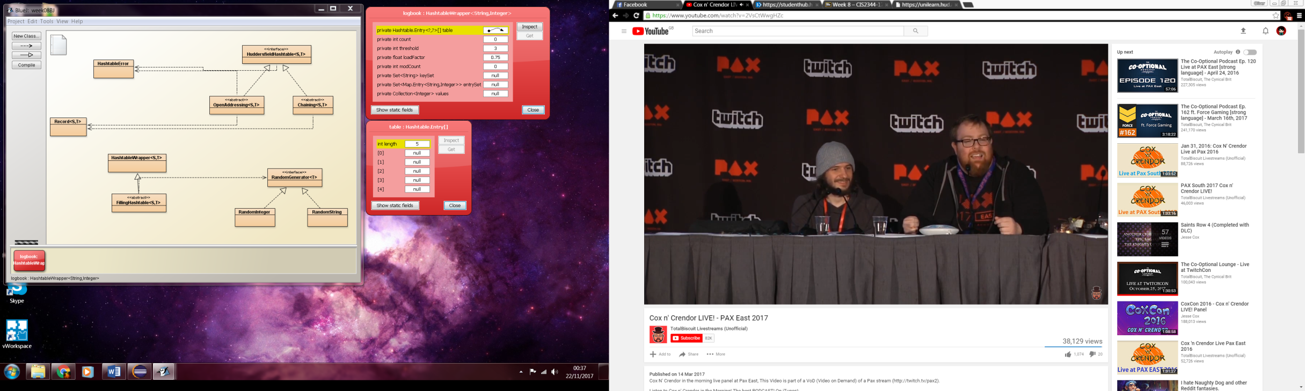

Figure 1(Above): Instantiation of a blank HashtableWrapper(String,Integer,5)

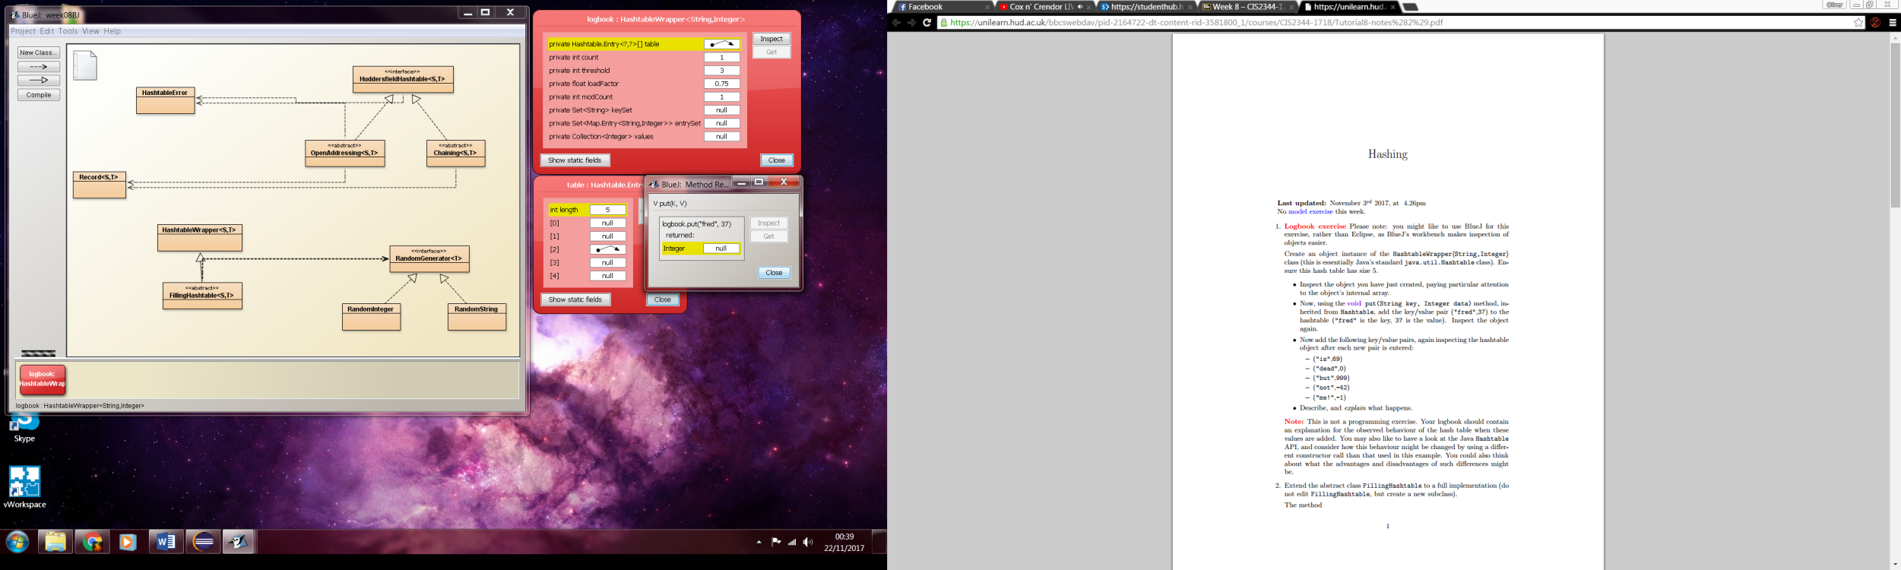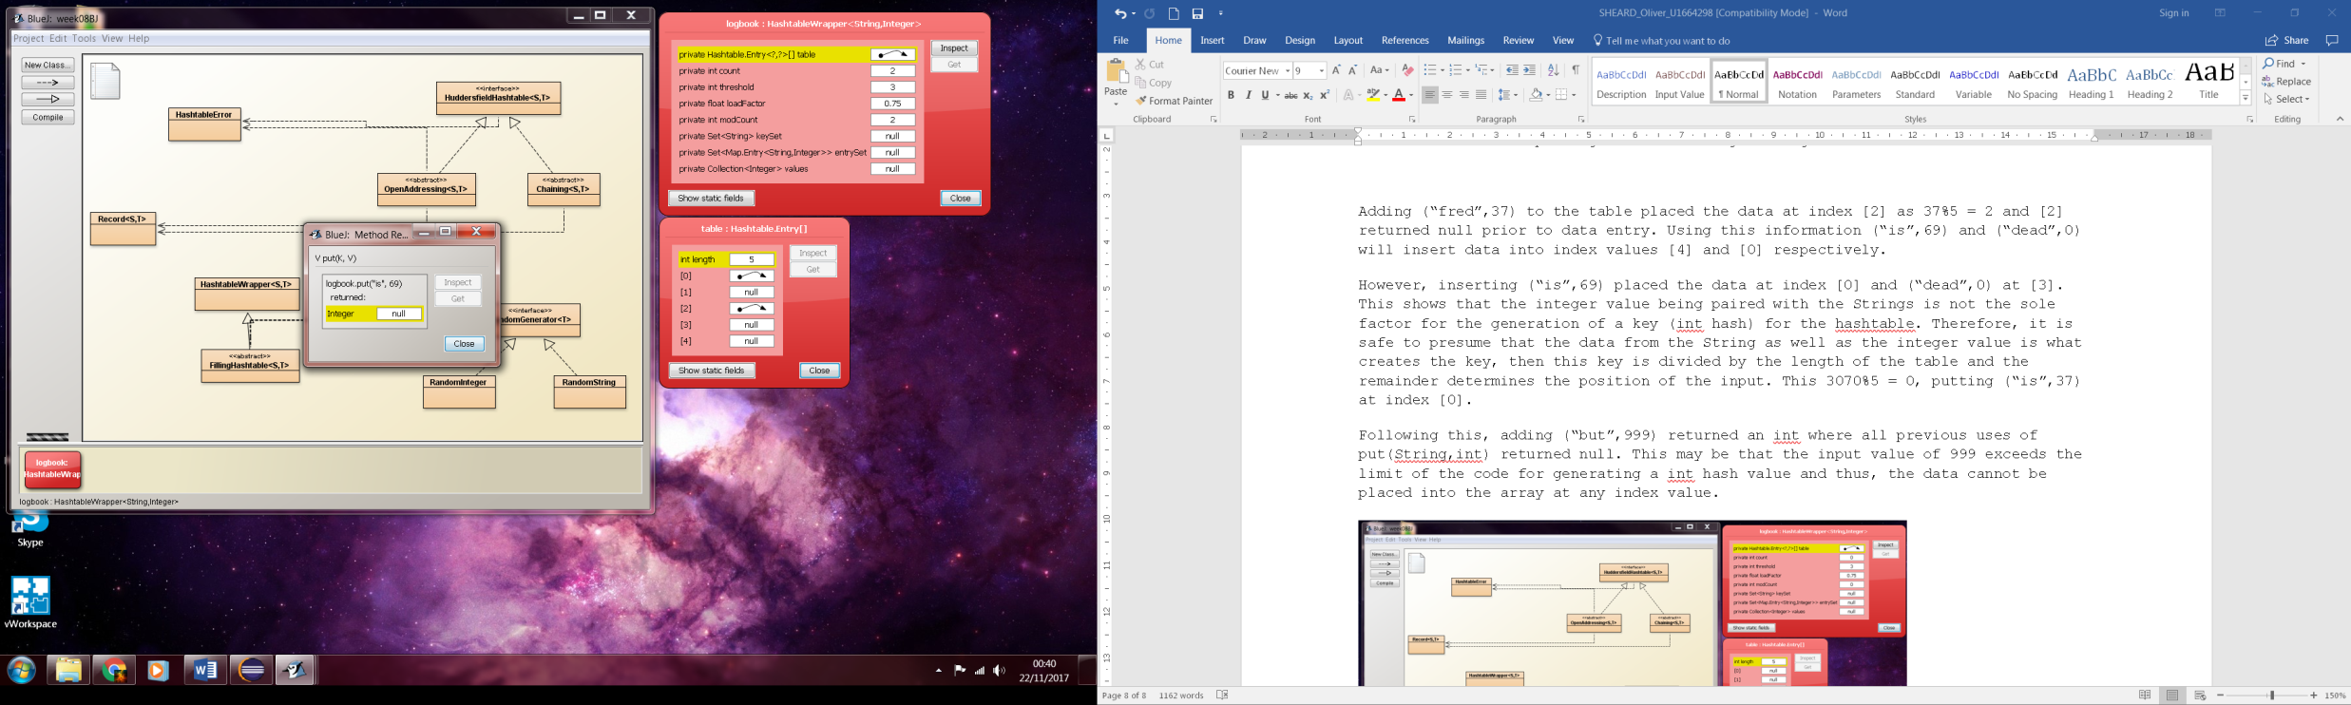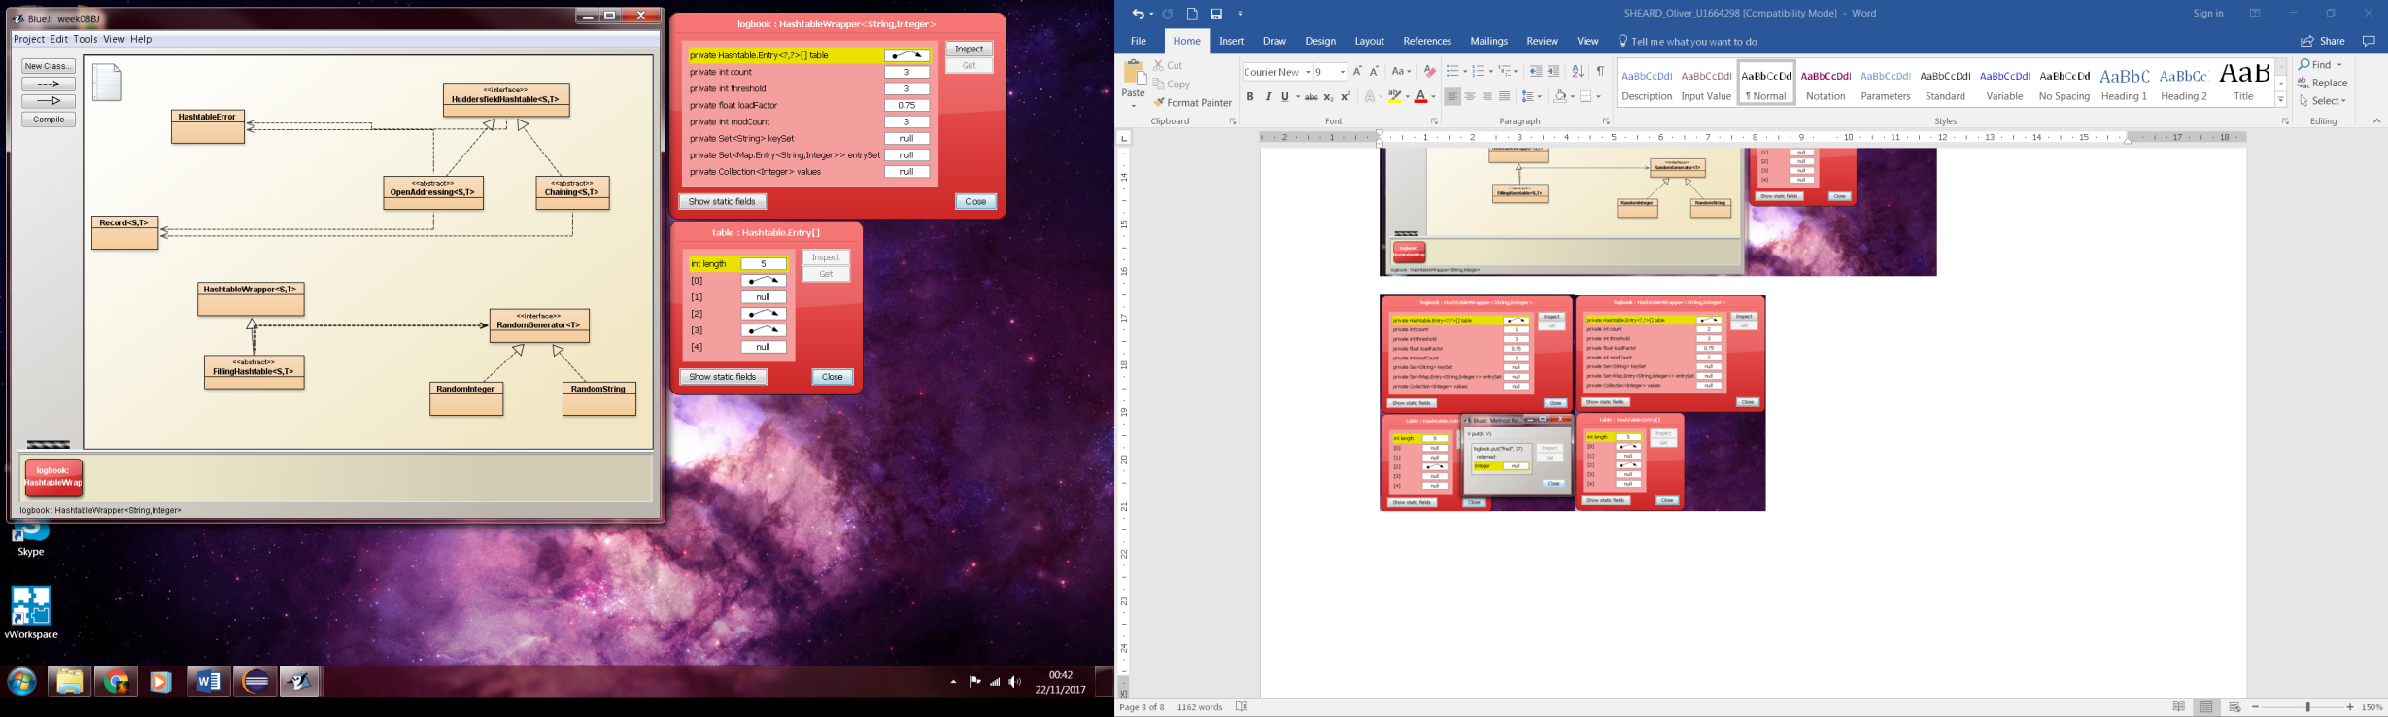

Figure 2,3 & 4(Above): Adding the data values (“fred”,37)(“is”,69) and (“dead”,0)

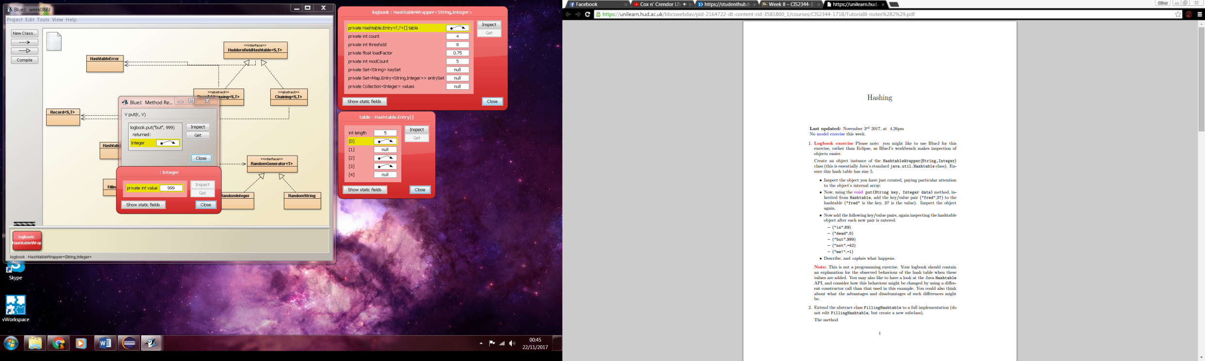 Figure 5(Left): Returned int from adding (“but”,999)

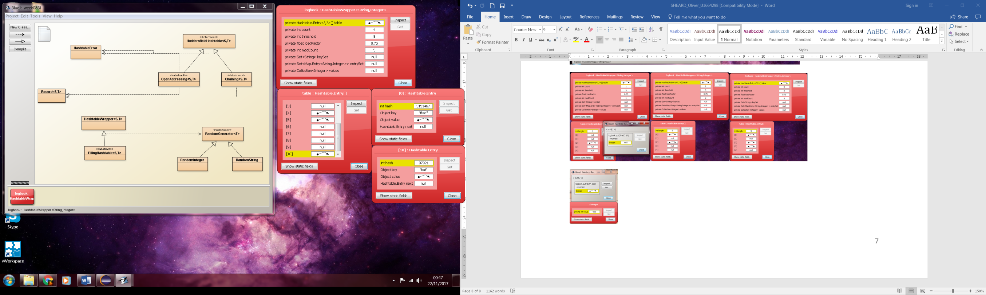 Figure 6(Left): Hashtable after adding (“but”,999)

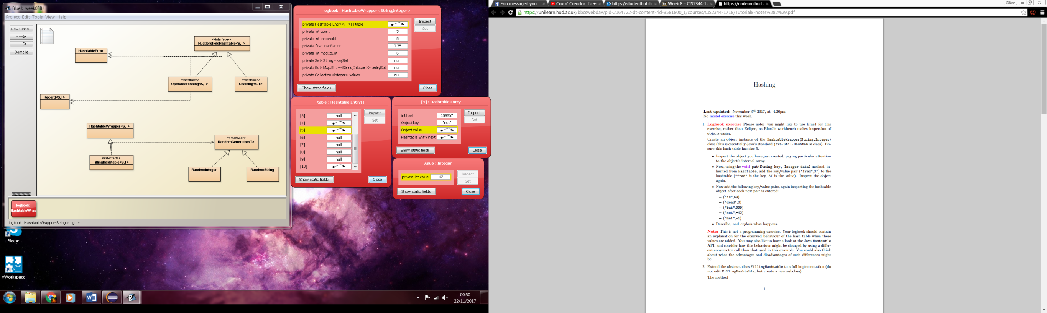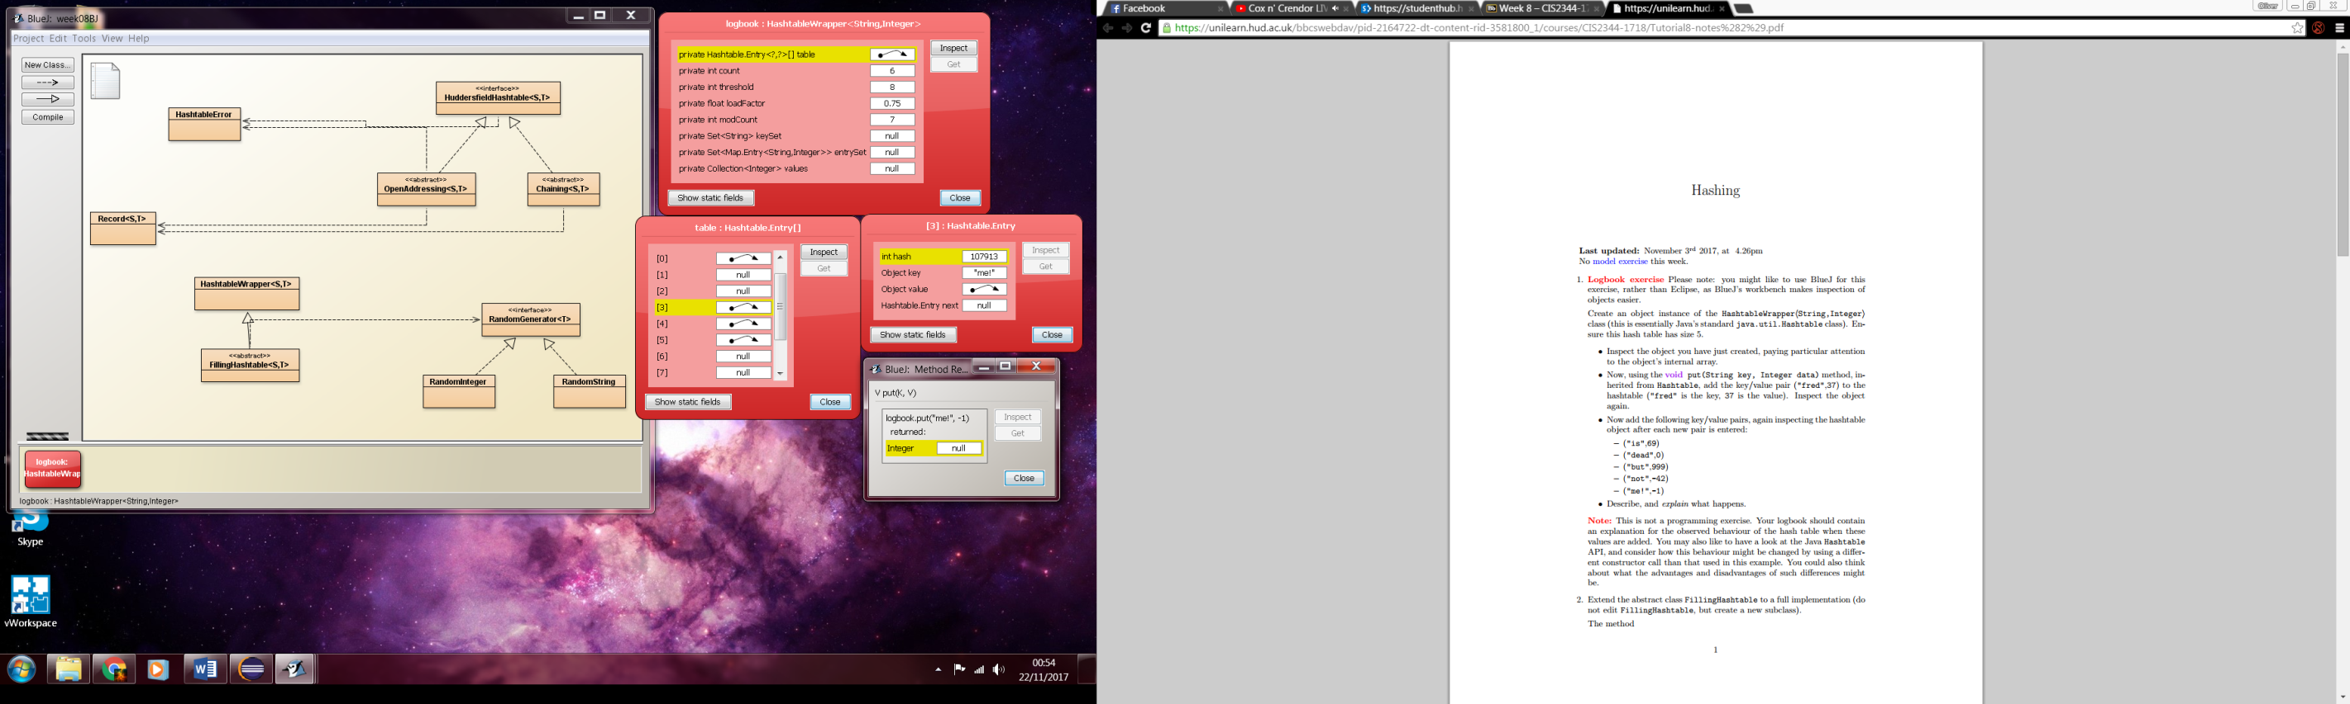

Figure 7 & 8 (Above): Adding the final data points of (“not”,) and (“me!”,-1)

Figure 1-4: Creating the Hashtable of length 5, then proceeded to add three values into the table. From this it appears as though the position in the hashtable is linked directly to the hash integer, with conflicts resolving as expected by pushing values further down the hashtable.

Figure 5 and 6: Once the hashtable reached the calculated threshold for the instantiated size (3, calculated from initial size of 5 and loadFactor of 0.75), the code took the data stored in the initial hashtable, created a new table 6 entries larger according to the modCount variable. With this larger table the old data was copied into the new table before adding the new value.

Week 10 – Graphs

**package** graph;

**import** java.util.List;

**import** java.util.ArrayList;

**public** **class** DepthFirst<T> **extends** AdjacencyGraph<T> **implements** Traversal<T>

{

**private** List<T> nodes, traversal = **new** ArrayList<T>();

**private** **int** size = getNodes().size();

@Override

**public** List<T> traverse() **throws** GraphError

{

**for**(**int** i=0; i<size;i++)

{

**if**(traversal.size() < size)

{

T startNode = (T) getNodes().toArray()[i];

**if**(!traversal.contains(startNode))

{

RecursiveTraversal(startNode);

}

}

**else** **break**;

}

**return** **null**;

}

**private** **void** RecursiveTraversal(T node) **throws** GraphError

{

traversal.add(node);

nodes.add(node);

T[] neighbours = (T[])getNeighbours(node).toArray();

**for**(**int** i=0;i<neighbours.length;i++)

{

**if**(neighbours[i]!=**null**&&!traversal.contains(neighbours[i]))

{

RecursiveTraversal(neighbours[i]);

}

}

}

}

Week 11 – Topological Sort

**package** graph;

**import** java.util.HashMap;

**import** java.util.List;

**import** java.util.Map.Entry;

**import** java.util.Set;

**public** **class** ReferenceCount<T> **extends** AdjacencyGraph<T> **implements** TopologicalSort<T>

{

**private** List<T> traversal = **null**;

**private** Set<T> graphCopy = getNodes();

**private** HashMap<T,Integer> countTable = **new** HashMap<T,Integer>();

@Override

**public** List<T> getSort() **throws** GraphError

{

setup();

sort();

**return** traversal;

}

**private** **void** setup() **throws** GraphError

{

initialize();

countRefrences();

}

**private** **void** initialize()

{

**for**(T node: getNodes())

{

countTable.put(node,0);

}

}

**private** **void** countRefrences() **throws** GraphError

{

**for**(T node:getNodes())

{

**for**(T neighbour:getNeighbours(node))

{

**int** i = countTable.get(neighbour);

countTable.put(neighbour, ++i);

}

}

}

**private** **void** sort() **throws** GraphError

{

**while**(graphCopy.size()<0)

{

sortNode(nextReferenceZeroNode());

}

}

**private** T nextReferenceZeroNode()

{

**for**(Entry<T, Integer> node:countTable.entrySet())

{

**if**(node.getValue()==0)//Node has 0 neighbours

{

**return** node.getKey();

}

}

**return** **null**;

}

**private** **void** sortNode(T node) **throws** GraphError

{

traversal.add(node);

graphCopy.remove(node);

}

}

Week 13 – Counter Behaviour

Currently the CountTest class will always fail when the delay is set to any value less than 0.001, while the system can handle having times with more decimal places it appears as though the computer cannot count quicker than the value the delay is set to.

Meanwhile, the minimum number of lines for the test with two counters running from 0 to 10 and 10 to 0 is 24 lines. Each counter outputs their start value, counts to the destination value and upon counting to it, prints another line declaring that the counter has finished, thus with a step of 1 and counting 11 values (as 0 is included in the counting) Finishing the count adds 1 line per counter and the two counters total 24 lines outputted by the test.

Week 14 – Railway System

**public** **void** runTrain() **throws** RailwaySystemError

{

Clock clock = getRailwaySystem().getClock();

Railway nextRailway = getRailwaySystem().getNextRailway(**this**);

Basket basket = getBasket();

**while** (!clock.timeOut())

{

choochoo();

basket.putStone(**this**);

**while** (nextRailway.getBasket().hasStone(**this**))

{

**if**(nextRailway.getBasket().hasStone(**this**) == basket.hasStone(**this**))

{

basket.takeStone(**this**);

**while**(nextRailway.getBasket().hasStone(**this**) != basket.hasStone(**this**))

{

siesta();

}

basket.putStone(**this**);

}

}

crossPass();

basket.takeStone(**this**);

}

}

}

Week 15 – Semaphores

critSec().P and noElts().P in the consumer of the Buffer class is denoted as part of the get() function, specifically the lines criticalSection.poll(); and noOfSpaces.poll();. By swapping these two lines over from each other, the only successful test will occur when the producer takes up less time than the consumer. When this is the case, multiple elements can be added to the buffer while it takes longer for an element to be removed, in this manner, as the first check for a removal occurs, multiple elements can be added to the buffer and thus an element will always be viable for removal.

critSec().V and noElts().V in the producer of the Buffer class is denoted as part of the put() function, specifically the criticalSection.vote(); and noOfSpaces.vote();.

Week 16 – Monitors and Locks

**package** resourceManager;

**import** java.util.concurrent.locks.Condition;

**import** java.util.concurrent.locks.Lock;

**import** java.util.concurrent.locks.ReentrantLock;

**public** **class** LockResourceManager **extends** BasicResourceManager {

**final** Lock resourceLock = **new** ReentrantLock();

**final** Condition[] conditions = **new** Condition[***NO_OF_PRIORITIES***];

**final** Condition inUse = resourceLock.newCondition();

**final** Condition notInUse = resourceLock.newCondition();

**boolean** resourceLocked = **false**;

**public** LockResourceManager(Resource resource, **int** maxUses) {

**super**(resource, maxUses);

**for**(**int** i=0;i<***NO_OF_PRIORITIES***;i++)

{

conditions[i]=resourceLock.newCondition();

}

}

@Override

**public** **void** requestResource(**int** priority) **throws** ResourceError {

resourceLock.lock();

**try**

{

**if**(resourceLocked)

{

increaseNumberWaiting(priority);

conditions[priority].await();

}

resourceLocked = **true**;

}

**catch** (InterruptedException e)

{

e.printStackTrace();

}

**finally**

{

resourceLock.unlock();

}

}

@Override

**public** **int** releaseResource() **throws** ResourceError {

**int** priority = ***NONE_WAITING***;

resourceLock.lock();

**try**

{

**for**(**int** i = ***NO_OF_PRIORITIES***-1;i>0;i--)

{

**if**(getNumberWaiting(i)>0)

{

priority = i;

**break**;

}

}

resourceLocked = **false**;

**if**(priority != ***NONE_WAITING***)

{

decreaseNumberWaiting(priority);

conditions[priority].signal();

}

**return** priority;

}

**finally**

{

resourceLock.unlock();

}

}

}

Week 17 – Circuits

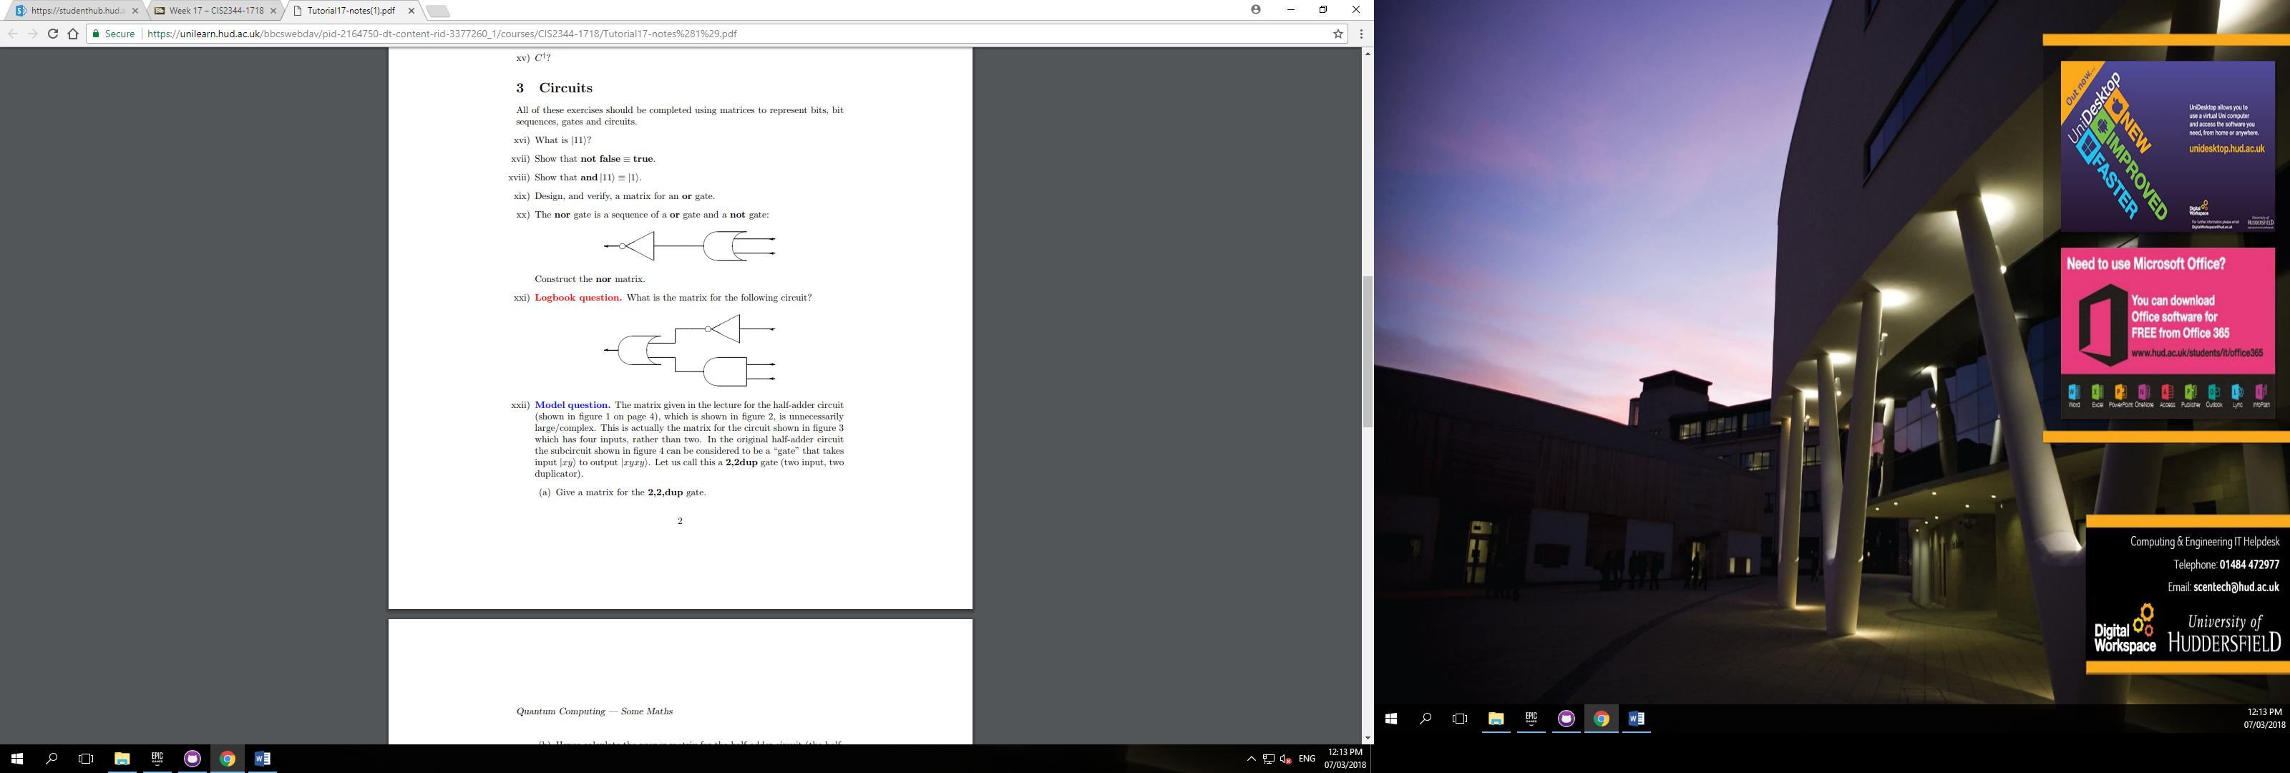This week’s assignment was to convert the following circuit diagram into a single matrix, for ease of understanding I have assigned the inputs in descending order A, B and C such that the overall circuit denotes the formula of ~A+(B∙C). Therefore, the matrix for this would be a combination of:

NOT (~A) denoted as

AND (B∙C) denoted as

OR denoted as

In MatLab this would be denoted as kron(NOT,AND)

Thus, ~A+(B∙C)as a matrix is

Truth table of the Circuit

|  |  |  |  |  |  |
| --- | --- | --- | --- | --- | --- |
| A | B | C | ~A | B∙C | ~A+(B∙C) |
| 0 | 0 | 0 | 1 | 0 | 1 |
| 0 | 0 | 1 | 1 | 0 | 1 |
| 0 | 1 | 0 | 1 | 0 | 1 |
| 0 | 1 | 1 | 1 | 1 | 1 |
| 1 | 0 | 0 | 0 | 0 | 0 |
| 1 | 0 | 1 | 0 | 0 | 0 |
| 1 | 1 | 0 | 0 | 0 | 0 |
| 1 | 1 | 1 | 0 | 1 | 1 |

Week 20 – Quantum Computing

**Self-Assessment**

Week ## (Self-Assessment Grade) - Reasoning

Semester 1 – Guidance Week

Week 01 (A) – admittedly required assistance with overcomplicating my initial approaches to resolving the logbook requirement, although now the code appears to be suitable in randomising the Arrays as shown by the test class.

Week 03 (A) – The code functions efficiently with generic variables as proven in the test classes created.

Week 05 (A) – Used own implementations of the Selection Sort and Quick Sort methods and proceeded to match the results with the known efficiency formulae (quadratic and quasilinear respectively), graphs could be improved upon by running the test more times and calculating a more accurate average and resolve issues brought by spikes of data shown on the graph

Week 06 ()

Week 07 ()

Semester 1 – Consolidation Week

Week 08 ()

Week 09 ()

Week 10 ()

Week 11 ()

At the end of the first semester I have noticed that some of my logbook work will require development of the Christmas period, notably there is a lack of test classes to some of the assignments. Beyond this there are two weeks that have proven to be somewhat more complex than anticipated, notably Week 6 – Lists and Week 11 – Topological sort. Although I had not attended the Week 6 tutorial due to personal commitments I was able to understand the effective “trick” to the solution. Meanwhile, with assistance via the tutorial in Week 11 I am still working on implementing the Topological Sort correctly.

Semester 2 – Guidance Week

Week 13 (C) – Relatively few occurrences regarding critical errors or faults in code discovered, points could probably be discussed further or more in depth providing hypothetical causes of the issues.

Week 14 ()

Week 15 (C) –

Week 16 ()

Semester 2 – Hand-in Week

Week 17 (A) Regarding the calculation of the matrix for the circuit presented, I believe that the work presented should sufficiently cover the requirements.

Week 20 –